Ruby Cheatsheet

Contents

Ruby Cheatsheet 1

Accessors 1

Arrays – Indexing 2

Code Blocks 3

Collections – Nested 4

Hashes – Associative Arrays 5

Rails Console – Starting 5

Rails Directory Structure 6

Regular Expressions 7

Variables 8

# Accessors

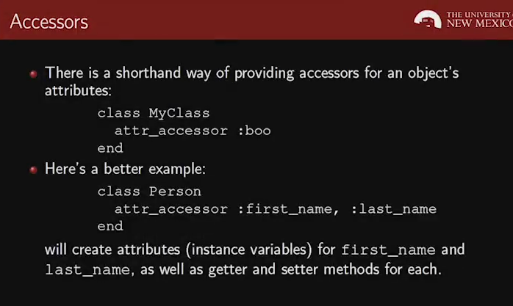

# Arrays – Indexing

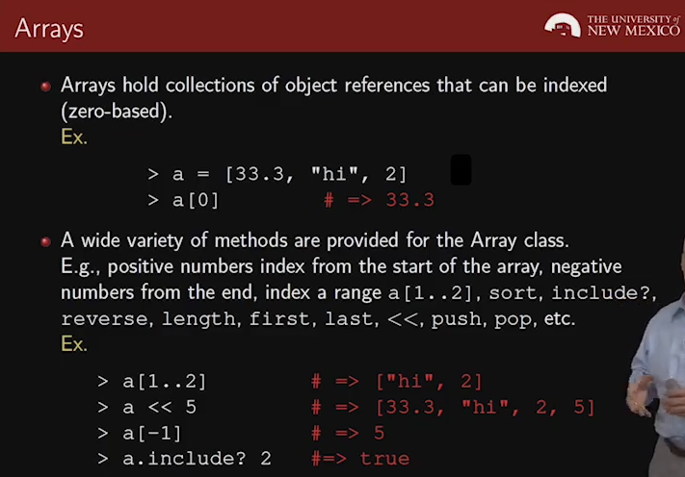

# Code Blocks

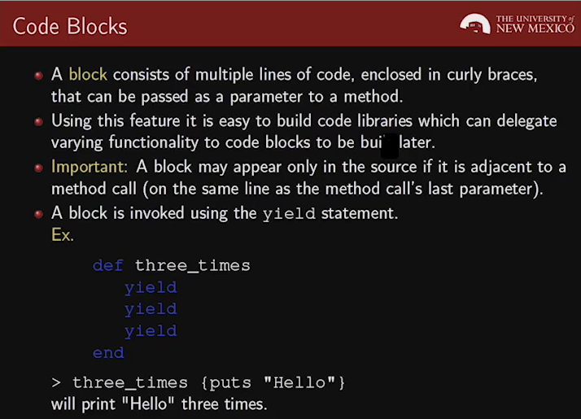

# Collections – Nested

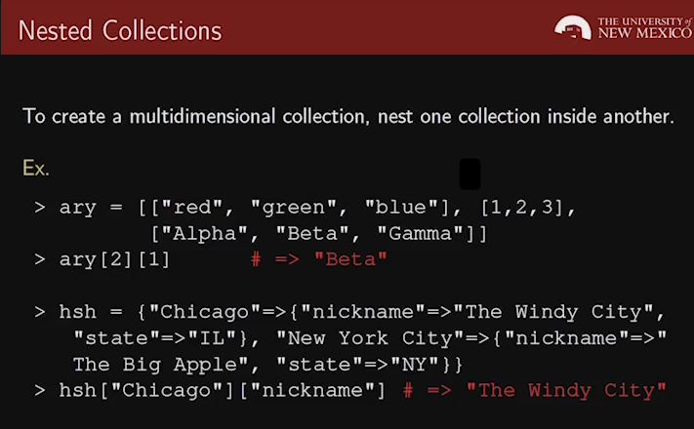

# Hashes – Associative Arrays

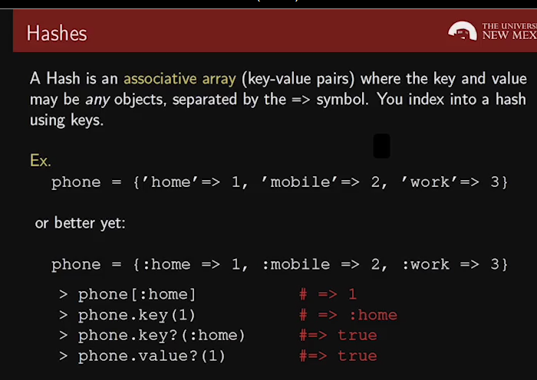

# MVC Architecture

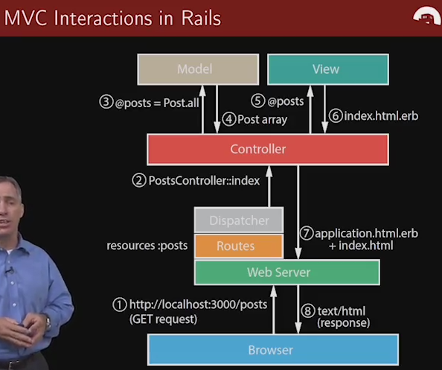

# Rails Console – Starting

c:\rails>cd my_app

c:\rails\my_app>rails console

Loading development environment (Rails 4.1.1)

irb(main):001:0>

# Rails Directory Structure

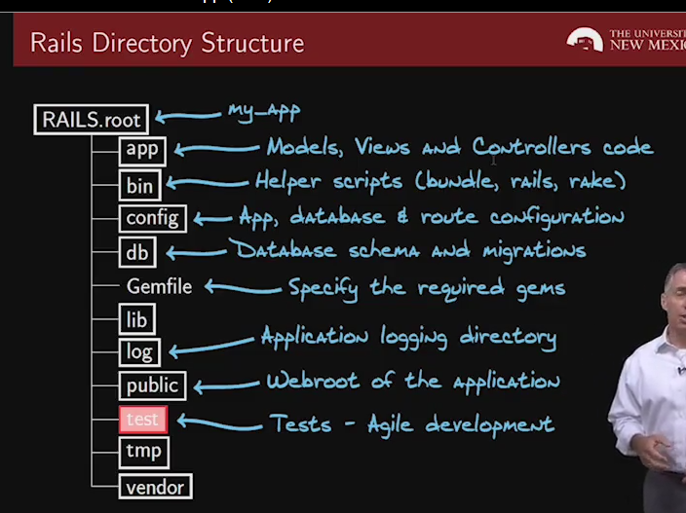

# Regular Expressions

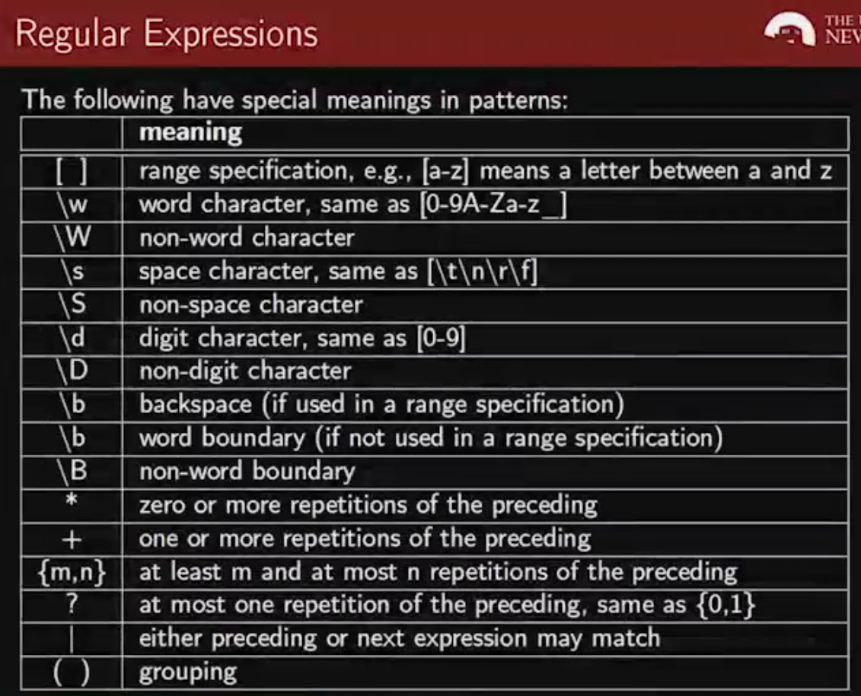

# Strings

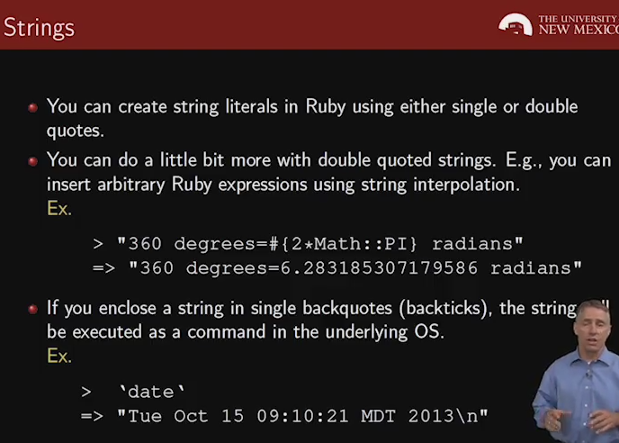

# Variables

